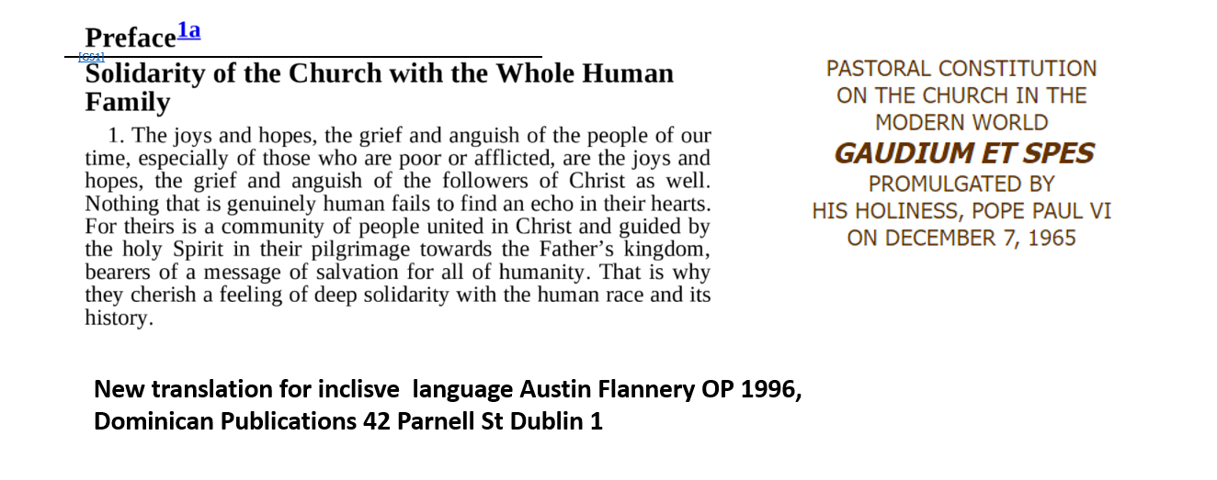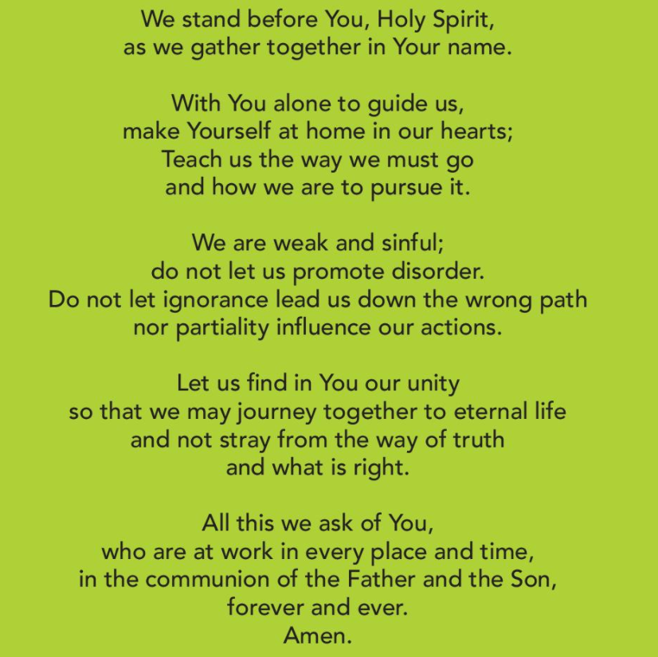

TABLE OF CONTENTS

Contents
Introduction. 3
General Details 5
THE JOYS 5
THE SORROWS 6
THE HOPES 7
THE FEARS 7
REFLECTION QUESTIONS 8
WHAT THEMES ARE EMERGING FROM THE GATHERING? 8
WHAT MIGHT THE HOLY SPIRIT BE INDICATING IN THIS? 9
Session 1 Question 1 Joy 10
Session 1 Question 2 Sorrow 16
Session 2 Summary Hope 23
Session 2 Fear and Anxiety 27

Introduction.
The animators: Sinead Fallon and Gerry Stockil would like to thank all who attended the Synod session of the 14th March ( 63) and 21st March ( 43), and to all in St Dominic’s and St Mary’s Parish who organised the synod. We also wish to thank the Synod Committee for organising this and Pope Francis for initiating this.
The first meeting (gathering, session ) was organised on Monday 14th March 2002 in the Maldron Hotel and dealt with two questions.

Question 1 : When you think of your experience of Church, what brings joy?
Welcome. You are invited to reflect quietly about this before you respond. This is about listening. All will be asked to share and say something. At the end of the session please write down your experience. Do not give your name when writing. All listening is confidential. The group leader will keep timing.

Question 2 : When you think of your experience of Church, what brings sorrow?

Welcome back. You are invited to reflect quietly about this before you respond. This is about listening. All will be asked to share and say something. At the end of the session please write down your experience. Do not give your name when writing. All listening is confidential. The group leader will keep timing.
These questions are called Joy and Sorrow.
The second meeting was organised on Monday 21st March 2022 in the Maldron Hotel Tallaght and dealt with the following questions.
 |  | Question 1 : When you think of your experience of Church, what brings hope?
Welcome. You are invited to reflect quietly about this before you respond. This is about listening. All will be asked to share and say something. At the end of the session please write down your experience. Do not give your name when writing. All listening is confidential. The group leader will keep timing. Please specify which parish you belong to.

St Dominic’s | St Mary’s | Other

 |  |  | Question 2 : When you think of your experience of Church, what makes you anxious or fearful?
Welcome back. You are invited to reflect quietly about this before you respond. This is about listening. All will be asked to share and say something. At the end of the session please write down your experience. Do not give your name when writing. All listening is confidential. The group leader will keep timing.
 | St Dominic’s |  |  | St Mary’s | Other
These questions are called Hope and Fear in the answers.
Everyone was given an A4 sheet on which to write their comments. Each question was considered for around 40 mins, follows by a coffee break, a prayer and then the second questions. Groups were divided into tables, some from the same parish although both parishes mixed. A special thanks to the small group organisers. Most of the attendees were older, there was a clear lack of younger people although a few were present.
The text of all the responses is in this document. These were dictated from the scanned document; in some cases some words were unclear and these are indicated. The original scanned document are provided separately in case people wish to check accuracy. Any lack of accuracy or missing response in unintentional, to the best of our knowledge all documents have been scanned and “dictated” ( converted to text by a speech to text program ). In a separate document SynodArchiveApril2022StMaryStDomincs.docx is a file with the scanned response of those who attended this is meant for diocesan and parish archives.
We ask that both this document and the above be placed in the Dublin Diocesan archive and in the parish archives of St Dominic’s and St Mary’s parishes Tallaght.
We have used part of the template provided by the Synod Committed, while is would be possible to highlight other issues if different people read it we feel the summary is a fair reflection of what was discussed, we ask all who are interested in analysing details to refer to actual text (in this report ) of what all the people read and to note that the scanned documents is the base information on which the text was produced.
We pray that the Synodal process will continue and bear fruit.
Christ is Risen
Sinead, Gerry
22 April 2022

General Details

NAME OF PARISH | NAME OF PASTORAL GROUPING
St Dominic’s and St Mary’s Priory Parish Tallaght Dublin 24 | St Dominic’s and St Mary’s Priory Parish Tallaght Synodal Group
VENUE OF GATHERINGS | IN PERSON OR ZOOM
Maldron Hotel Tallaght | In person
NUMBER OF PARTICIPANTS(1st Gathering) | NUMBER OF PARTICIPANTS (2nd Gathering)
63 | 43

THE JOYS
WHAT EXPERIENCES ARE NAMED AND CONVERGE? | No. | WHAT EXPERIENCES ARE NAMED AND DIVERGE? | No.
- Sacraments/Eucharist/Mass  - The Gospel of Jesus Christ and personal experience of the relationship to God  - Community, gatherings, worship together etc.  - Presence of the Youth in the Church  - Faith in this Synod and Pope Francis to brig some changes to the Church  - Prayers individual and in the community 10+  - Mary mother of God (mentioned by a few but with such fervour)  - Keeping in touch with the priests, their availableness after mass etc.  - Celebrations in the community, the faith of the elders as a great example, and sandal listening process as a great example of how to talk to the young members of the families. | 25+  22+  18  12  11  10  8  8  2-3 | No apparent divergences. | 0

THE SORROWS
WHAT EXPERIENCES ARE NAMED AND CONVERGE? | No. | WHAT EXPERIENCES ARE NAMED AND DIVERGE? | No.
1). Scandals, paedophilia, abuse in Church and sins of the clergy / nuns, cover ups, victims left alone with no help, responsibility not taken in actions.  2). Small number of the people attending to the Church especially the Young.  3). Lack of Faith and Joy in the Church and the clergy visible during the mass and sacraments, sad church  4). Institutional Church and rules above the Gospel of Jesus and Kerugma in Church life.  5). Quality of the sermon, teachings and sacraments (low Focus on the Gospel, Lack of Bible explaining the deep sense of the Sacraments)  6). Poor woman treatment and involvement in the life of the Church  7). Wealth in the Vatican, Bishops and rotten morals of the privilege clergy as a strong negative source of the influence in Church is a fear of many  8). No vocations is a great fear  9). Minorities in the church as a divorced people, gay, women and others seems to be not welcome in the Church.  10). Lack of faith formation is some instances and lack of respect, in some instances, for sacraments.  11). The fact that innocent people (priests and nuns) are blamed for the scandals.  12). Lack of faith in the Church in general today.  13). The rest are a fear of the renewal in the Church, willing to rethink the celibacy obligation, a need of the priests being more among the people, lack of change for people to come back after scandals, languages in the church not suitable for these days, hypocrisy and judgmental approach to Young or children in the Church. Importance of silence vs Young and children who are vivid and loud. Poor communication between Young and old in the Church. | 25+  22  16  16  16  14  13  11  11  10  6  6  >5 each | People see the scandals are the main reason for small number of the lay people in the Church. The way it was handled was often a sorrow of many. They mentioned people or themselves being ignored and left out without any support and help for the victims. They say the great sorrow is that the clergy responsible for scandals still did not took enough responsibility for their actions and that the nuns scandals known by many was handled poorly or wasn’t handled at all by the Pope himself and the bishops.  In many cases clergy are praised, in some cases masses are out of life, sermons boring, not related to the Gospel or the daily readings.  People expect from the priests to explain the liturgy and the readings of the Bible instead of moralising.  The wealth of the Church should be given to the poor some said.  Some clergy out of touch, some people search for the support from them some help or individual prayers but there is no response. Voices that priest do not answer for the spiritual needs of the lay people.  Some indicate a focus on “rite” only instead of the core message but this is not particularly strong.  Some people say that younger priests are too “conservative”. Another say there is a watering of the Gospel and there is no faith in the priests and people. Most of them lack the faith of the first Church and the true Gospel of Jesus.  Many suggest a great role for women, some suggest deacons, and some suggest the priesthood, some voice state that women cannot be ordained. Most seem to mention “a greater role” rather than an outright call for ordination.  Some said there was not much done after Vatican II, also the promise for the women deacons did not come to pass.  Ignoring minorities, women, divorced, separated and gay people who are technically welcome in the Church; however some say lack of progress and mistreating them in the Church keeps them to stay away.

THE HOPES
WHAT EXPERIENCES ARE NAMED AND CONVERGE? | No. | WHAT EXPERIENCES ARE NAMED AND DIVERGE? | No.
Many of the Joys are repeated.  God is in charge.  Importance of Hope  The goodness of young people.  Personal faith a great source of hope.  Bible and formation in the Church.  Gathering in the Church, hope for Churches to stay open. |  | There is no significant divergence. Perhaps the different between a Joy ( a present thing ) and a Hope ( something for the future ) are seen as the same thing.

THE FEARS
WHAT EXPERIENCES ARE NAMED AND CONVERGE? | No. | WHAT EXPERIENCES ARE NAMED AND DIVERGE? | No.
Lack of priests.  Reforms may not happen.  Some fear Church closures.  Lay involvement welcomed but a few say that lay involvement could be selective, and some lay people exclude others.  A good few mentioned mandatory celibacy as being a problem and one sees it as unnatural.  Seeking the “wrong progress” in the Church. |  | That the Synod may water down the Church’s teaching and be a source of division.  Curia or lobby in Vatican may hamper the reform.  The following concerns are mentioned by some  That the church waters down picks and chooses its teaching.  That young people do not know enough about Church of Jesus Christ how can they make a choice then to accept or reject it  The church is investing more in ‘renewal’ than peace prayer and faith and a great number puts their hopes in the renewal in the Church,  Fear of the over institutional Church might kill the Gospel.  Others fear for overemotional charismatic groups lead the Church in the wrong directions.

REFLECTION QUESTIONS

WHAT THEMES ARE EMERGING FROM THE GATHERING?
The continuing importance of the Mass, sacraments, and prayer.

Experiencing the community in the Church as almost important factor to grow in faith together.

Keeping a focus on preventing scandals worldwide, acknowledge those that are happening or have happened, acknowledge the cover up where this is the case, and healing this terrible wrong while remembering that many are saddened that very often many innocent clergy and nuns are "apologizing" for something they themselves did not do. People expect serious reaction and actions in this matter.

Patient consideration for all the ways of reaching out and sending the Christian message to all especially the lapsed or non-practicing, and the young, because the message of Christ, and the true Message of the Church properly understood and proclaimed brings Healing and Life to all even in the world remains sinful and challenging and complex ,yet is still God's good creation..

Use the Synod as process of prayer and renewal and guidance by the Holy Spirit.

Working on the quality of the liturgy, sermons, going back to the Gospel of Jesus teaching, to the Bible understanding in general in the churches is a great need and hunger of many.

Worry that the scandals still need to be fixed worldwide.

People are hoping for the changes but also scared that their voices will not be listened or the lobby’s in the Church might block the revival and renewal in the Church.

The role of women needs to be strengthen, they need to be given real power and significant roles. A strengthen role includes a spectrum of statements: more power, deacons and full priesthood, there is no particular agreement on this.

Young people need to attracted back and patient initiates need to be put in place.

Lack of priests is a worry and changes to the celibacy rule may address some of this problem.

Separated/divorced are not always welcome in the Church and this needs to be addressed.

Some people seem clearly in favour of reform on teaching of inclusion of women, gay people, separated/divorced couples and mandatory celibacy; however few state exactly what this reforms might be. Some warn against a watering down of teaching.

Issues relating to minorities in the Church as a divorced people, gay people, the role of women, have been a source of debate (sometime very bitter debate in some circles from both “wings”) and an accommodation needs to be found between the “progressives” and “conservatives”.

WHAT MIGHT THE HOLY SPIRIT BE INDICATING IN THIS?
1. It is time to take serious actions as a response to abuse and dark past of the Church. Many are in trauma or rejection, Priests either ignore or blame themselves or others. No serious actions being taken. No help for the victims. Just avoidance, distance and shame.

2. People need to hear more of The Gospel, they need a true Faith based on knowing and understanding the Bible. They need a quality sermon, knowledge of the God not the opinions or stories in homilies. They need to know Jesus and wait for the change in the Church. They rely on The Holy Spirit.

3. People need the community more than ever. They miss gatherings especially during the pandemic. They fear for Churches being closed again.

4. The voices are that they need the Church looking more like the one Jesus created not the rotten institution we see now. They wait for all to be included and involved without judgement, especially the weak, women, children, LGBTQ, young.

5. Many voices for The Holy Spirit to bring the meanings of the Church as people in Christ. Bishops or clergy being less in charge and privilege more as being servants as Jesus to His disciples and teachers of the Gospel the message of Love of God instead of judging, dividing and being above people.

